**Email with signature block**

Emails are business letters and are subject to the Demag Corporate Design guidelines as part of corporate communication. The following specifications apply to the structure of the email, the sender information, the signature block and the email footer.

The standard font is Arial (10 pt). Other fonts may not display correctly for the recipient.

Mit freundlichem Gruß / Best regards

|  |  |  |
| --- | --- | --- |
| Your local site Street No. Zip-code City   [**demagcranes.com**](https://www.demagcranes.com) |  | **Demag Cranes & Components GmbH**  **First name Surname Title / Function**  **T**  +49 2335 92 1234 **M**  +49 170 123 4567 **E**  [name.surname@demagcranes.com](mailto:name.surname@demagcranes.com)  [Obligatory Disclosures/Pflichtangaben](https://www.demagcranes.com/en/e-mail-signature) |

The example shows the standard for external emails. **Note: The contents of the box can simply be copied and pasted and then adjusted accordingly**.   
For internal communication, the signature block can be reduced to greetings and names. Campaign footers are distributed by Demag Marketing and must be placed under the informal signature during the campaign period.

Please create your personal signature in Outlook as described below.

In Microsoft Outlook, use the following menu commands to create or edit your email signature.

1. Open Outlook
2. Click on “File”

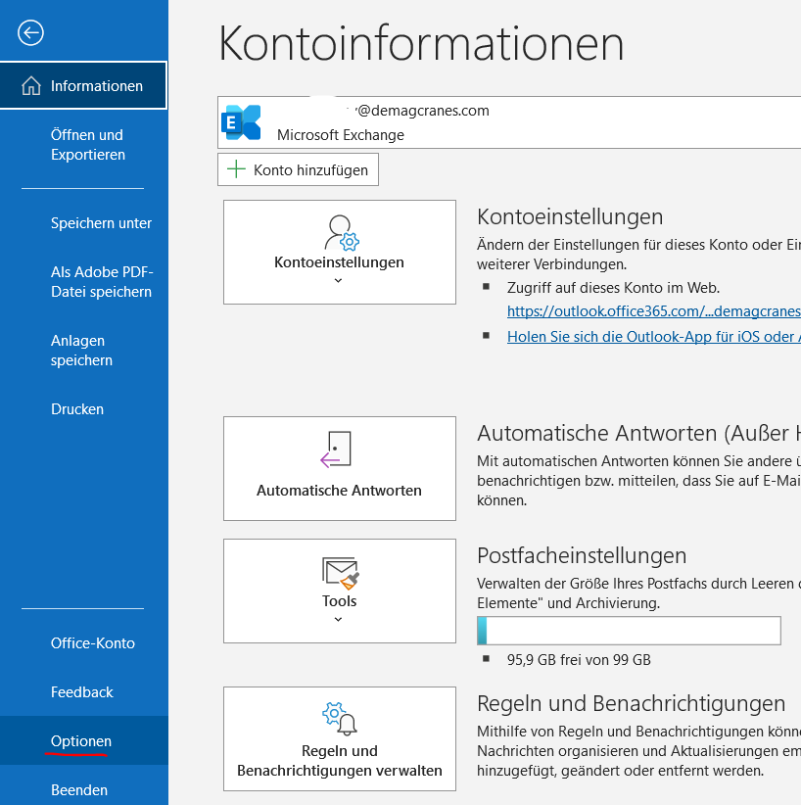

3. Click on “Options”

4. Click on “Email”

5. Click on “Signatures”

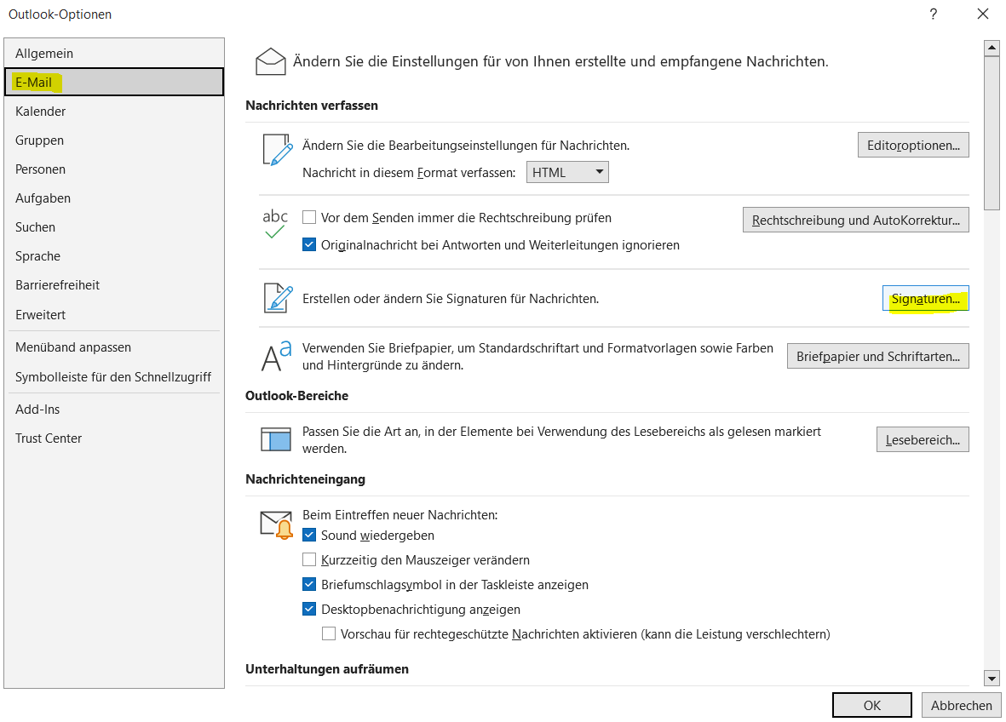

6. Click on “Email signatures”

7. Click on “Edit”

8. Create your signature as specified.

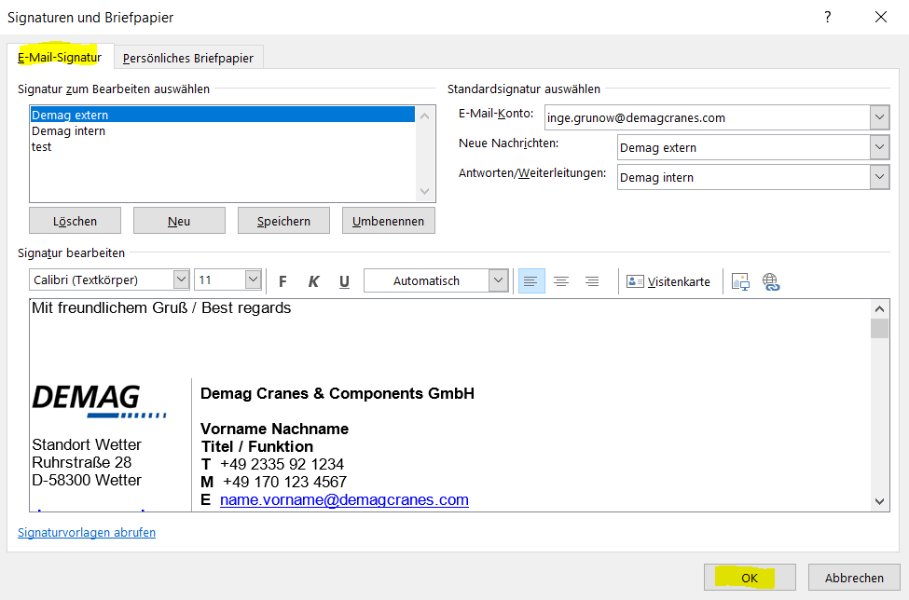

10. Click OK until all the pop-up windows are closed.

11. Test your new email signature by sending yourself a test email. As Outlook does not always recognise the font from the copy, it may be necessary to correct the font manually.